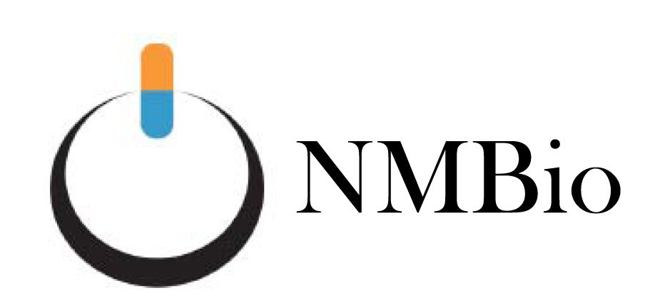

NMBio Sponsors Scholarship in Biomedical/Biotech Field

February 23, 2016 –The New Mexico Biotechnology & Biomedical Association (NMBio) is offering a $1,000 Scholarship to be presented to a New Mexico high school senior graduating in Spring of 2016. The student receiving the scholarship must meet the following criteria:
1.) be a U.S. citizen or permanent U.S. resident with a green card
2.) be a legal New Mexico resident for a minimum of one year
3.) be graduating from an accredited public or private high school
4.) be accepted to a two- or four-year accredited New Mexico college, and
5.) plan to major as a full-time student in an area that will lead to a career in a biotechnology or biomedical field

To apply, use the form on the reverse side and include: a one-page letter of intent in which the student describes his/her biomedical or biotechnology career goals. Also include documentation of acceptance to the New Mexico college, an official copy of the high school transcripts, a current teacher letter of recommendation, and SAT or ACT scores.

Apply by June 1, 2016 to: admin@nmbio.org

or mail to: NMBio Scholarship
P.O. Box 80233
Albuquerque NM 87198-0233

This application form is for the high school senior graduating in the spring of 2016 to apply for the NMBio scholarship for the 2016-17 college/university academic school year.

Personal information:

Name:______________________________________________________________________________
Permanent mailing address:_____________________________________________________________
City/State:________________________________________________________Zip________________
Name of parent(s) or nearest relative:______________________________________________________
Current mailing address (if different from above):
________________________________________________________________Zip_________________
Permanent Phone Number:______________________________________________________________
Current Phone Number:________________________________________________________________
E-Mail:_____________________________________________________________________________
Date of birth: ____/_____/_____
Top of Form
Gender: Female Male
Are you a U.S. Citizen?: Yes No If no, what is your green card number? ________________

How long have you been a legal New Mexico resident?:______________________________________
List three professions or occupations you have seriously considered:__________________________________________________________________________

Educational information:

High School:__________________________________Date of Graduation:_______________________
Mailing Address:______________________________________________________________________
City/State:________________________________________________________Zip________________
Principal:__________________________________________Phone Number:_____________________
GPA (through 7th semester):_____________________________________________________________
Name of High School Counselor:_______________________Phone Number:_____________________
Name the ONE college/university you will attend:___________________________________________

_____________________________ _____________________ ____________
Student Signature Name Printed Date

_____________________________ _____________________ ____________
Parent or Guardian Signature Name Printed Date

I (we) certify that all of the information on this form is true and complete to the best of my (our) knowledge…

Bottom of Form

